The Beihang-York 2015 Summer School

The Sino-Canadian Center for Social Sciences
The Sino-Canadian Center for Social Sciences (“the Center” hereafter), which was jointly established by Beihang University and York University in 2012, is a platform built on the basis of the existing framework of the collaboration between the two universities.
The Center aims at:
● Promoting all-round cooperation between Beihang University and York University in the humanities and social sciences.
● Enhancing the international level of the humanities and social science disciplines of Beihang University.
To promote student exchanges and joint training programs is one of the highest priority objectives of the Center.
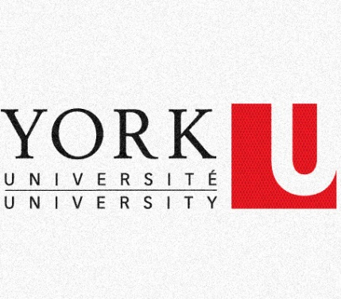
Beihang-York Summer School
Beihang-York Summer School is one of the substantial cooperative programs of the Center, from the first session in 2013, the summer school will be held annually with York University and Beihang University hosting in turn.
In the summer of this year, the third session of the Summer School will be held in York University, Canada.

York University
The University
York University is worldly recognized as of leadership in disciplines as literature, business, environmental studies, education and fine arts.
11 faculties & schools in York University:
● Faculty of Education
● Faculty of Environmental Studies
● Faculty of Fine Arts
● Glendon
● Faculty of Graduate Studies
● Faculty of Health
● Lassonde School of Engineering
● Faculty of Liberal Arts & Professional Studies
● Osgoode Hall Law School
● Schulich School of Business
● Faculty of Science
Some faculties and Schools of York University are in a leading position in Canada. For example, Schulich School of Business is the No. 1 business school in Canada, and Osgoode Hall Law School is one of Canada’s top law schools.

The Campus
There are two campus of York located in the heart of the Greater Toronto Area (GTA). One is Keele Campus (where we will be accommodated), the main campus of York University, which is also the campus we stayed in; the other is Glendon Campus, where French is mainly spoken.
Keele is one of the largest university campuses in Canada (large as 457 acres). It has beautiful scenery close to nature, walking around the campus you can see gooses, squirrels and even raccoons.
Library is opened almost the whole day with different restaurants served for students. In the hall, students are freely playing the guitar or discussing their group project – this is an inspiring place for university studies and a great backdrop for relaxing outside of class.
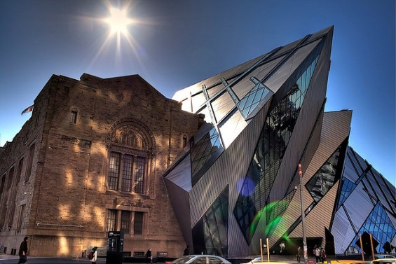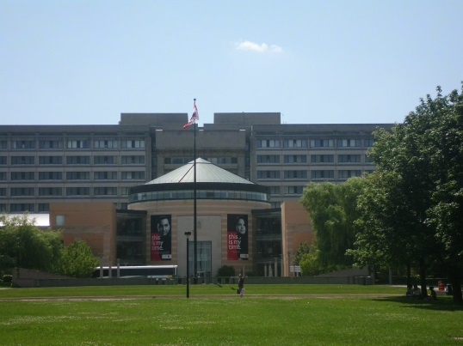

Memories: 2013 and 2014 Summer School
2013 Summer School – An Excellent Start
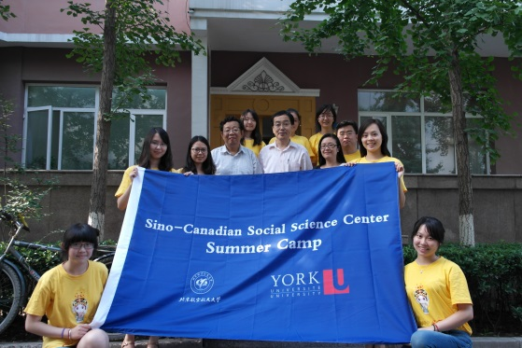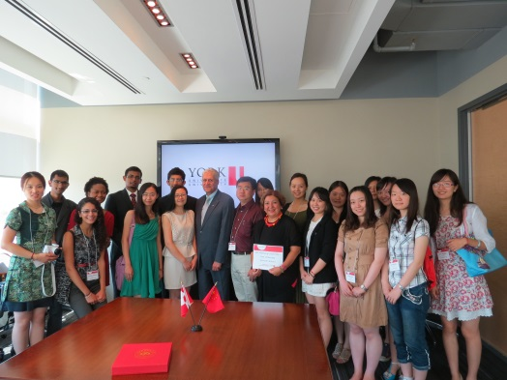

2014 Summer School – Friends Came Back
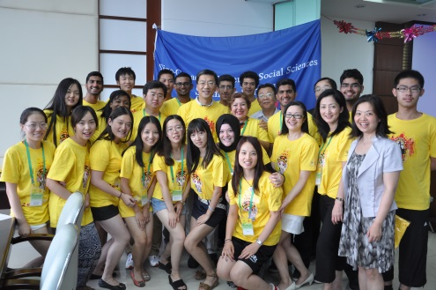
New Adventures: 2015 Summer School
Duration
July 11th, 2015 (departure from Beijing) – July 25th, 2015 (arrival at Beijing)
Expenses
15000 RMB per capita in total, including:
● Round trip (Beijing-Toronto-Beijing) air tickets
● Course fee of the Summer School
● Accommodation expenses in Canada
● Breakfasts and lunches in the Summer School (only in weekdays)
● One or two Collective dinners in Canada (depending on the specific circumstances)
● A visit Niagara Falls (rental fees, parking fees and tickets)
Each participant should also pay:
● Visa fee
● All supers, and breakfast and lunches in weekends in Canada
● Local transportation expenses in Canada
● Other individual expenses
Activities
●Lectures (Summer school courses) – Canadian economy, politics, culture and customs
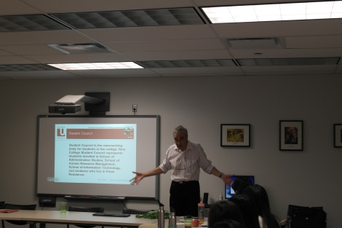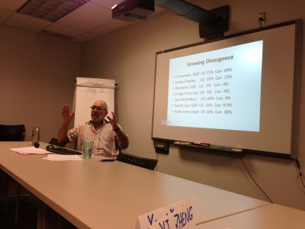
●Group projects – to cooperate with the students of York University
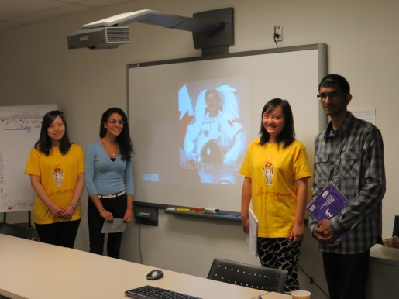
●Canada horizons – to visit Canadian museums and famous scenic sites
A Multicultural Journey
●New experiences
●New friends
●New understandings
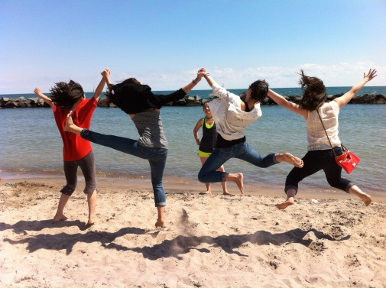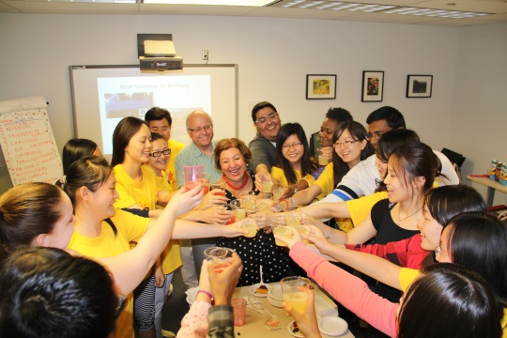
Requirements for Application
●The number of recruitment
10 students (graduate and undergraduate)
●Qualifications of Application
●Procedures & Materials
●Other Requirements
●Contact

