意大利圣安娜大学2015年暑期学校 高研院知行文科实验班暑期游学西方线路
西方文明与文化：文艺复兴与现代

主题 | 西方文明与文化：文艺复兴与现代  （Western civilization and culture: Renaissance and Modernity）
项目介绍 | 2015年意大利顶级国立精英贵族制大学 —— 圣安娜大学携手北航人文与社会科学高等研究院以“西方文明与文化：文艺复兴与现代”为主题，通过在圣安娜大学相关内容的课程学习与文艺复兴各历史中心的实地考察，并访问意大利的世界知名大学、现代企业，时尚行业和传统工业，使同学们深入了解西方文明文化尤其是以文艺复兴发源地著称的意大利的精髓，亲身体验世界一流学府的教学科研氛围，领略意大利独有的人文魅力和风土人情，开拓国际视野，增强跨文化交流能力和创新能力，提升国际理解力和竞争力。  课程结束后可认证北航相关公选课程2学分。
项目时间 | 2015年8月29日-2015年9月10日 |  |  | 选派人数 | 20-30人
访问国家 | 意大利
活动安排 | 1. 理论教学  a) 西方文明文化、文艺复兴相关理论  b) 意大利日常用语短期培训  c) 小组project  2. 实践教学之城市  参访罗马、威尼斯、佛罗伦萨、比萨、博洛尼亚、沃尔泰拉等文艺复兴著名城市及城内联合国教科文组织世界文化遗产，体验独有的城市文化和风土人情  3. 实践教学之博物馆  参观梵蒂冈博物馆、乌菲兹美术馆、学院美术馆、威尼斯贝利尼博物馆等世界知名博物馆，领略文艺复兴的美术、雕塑、建筑之美  4. 实践教学之传统工业与现代企业  参观意大利著名的菲亚特集团及时尚企业，参观传统作坊，体验现代化与历史相结合的文化之美  5. 实践教学之世界知名大学  比萨高等师范学校(意大利国立顶级精英贵族制高校)，圣安娜大学（意大利国立顶级精英贵族制高校），比萨大学（伽利略母校）、佛罗伦萨大学（知名大学）、博洛尼亚大学（世界最古老大学）等
项目费用 | 30000人民币 (含机票及签证费用及在意大利课程、考察、吃住行)
申报条件 | 1. 我校全日制、非委培、非定向的大学本科生和硕士研究生  2. 学习成绩优异，综合能力突出  3. 熟练掌握英语，听说读写流畅，能够参与发言、讲座、交流
申请所需  提交材料 | 1. 申请书（中、英文书写）
申请流程 | 1. 请于2015年4月10日24:00前将申请表发送邮件至 chenqi2013@buaa.edu.cn (邮件命名格式：“summer school application-姓名”，文实班学生请在邮件中注明。)  2. 4月20日评审确定最终人选并发布录取通知。
联系人 | 陈绮 | 联系方式 | 18600084927  chenqi2013@buaa.edu.cn
附件 | 1.暑期学校详情介绍； 2.《圣安娜大学2015暑期学校申请表》

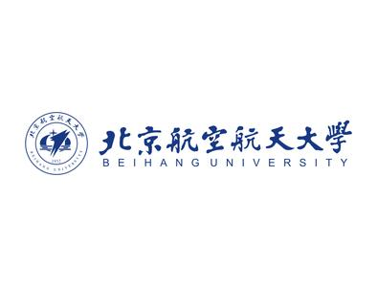
附件 1：
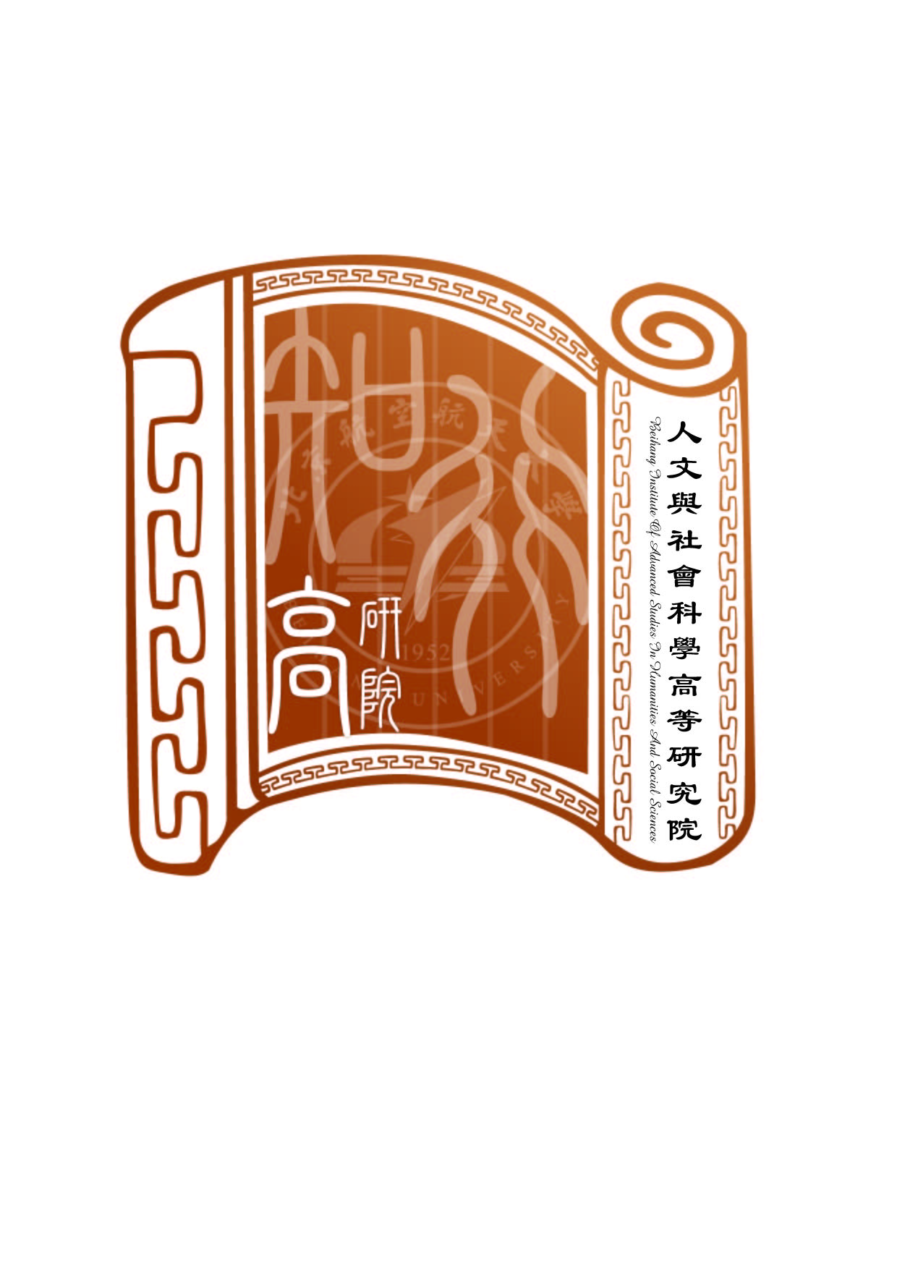
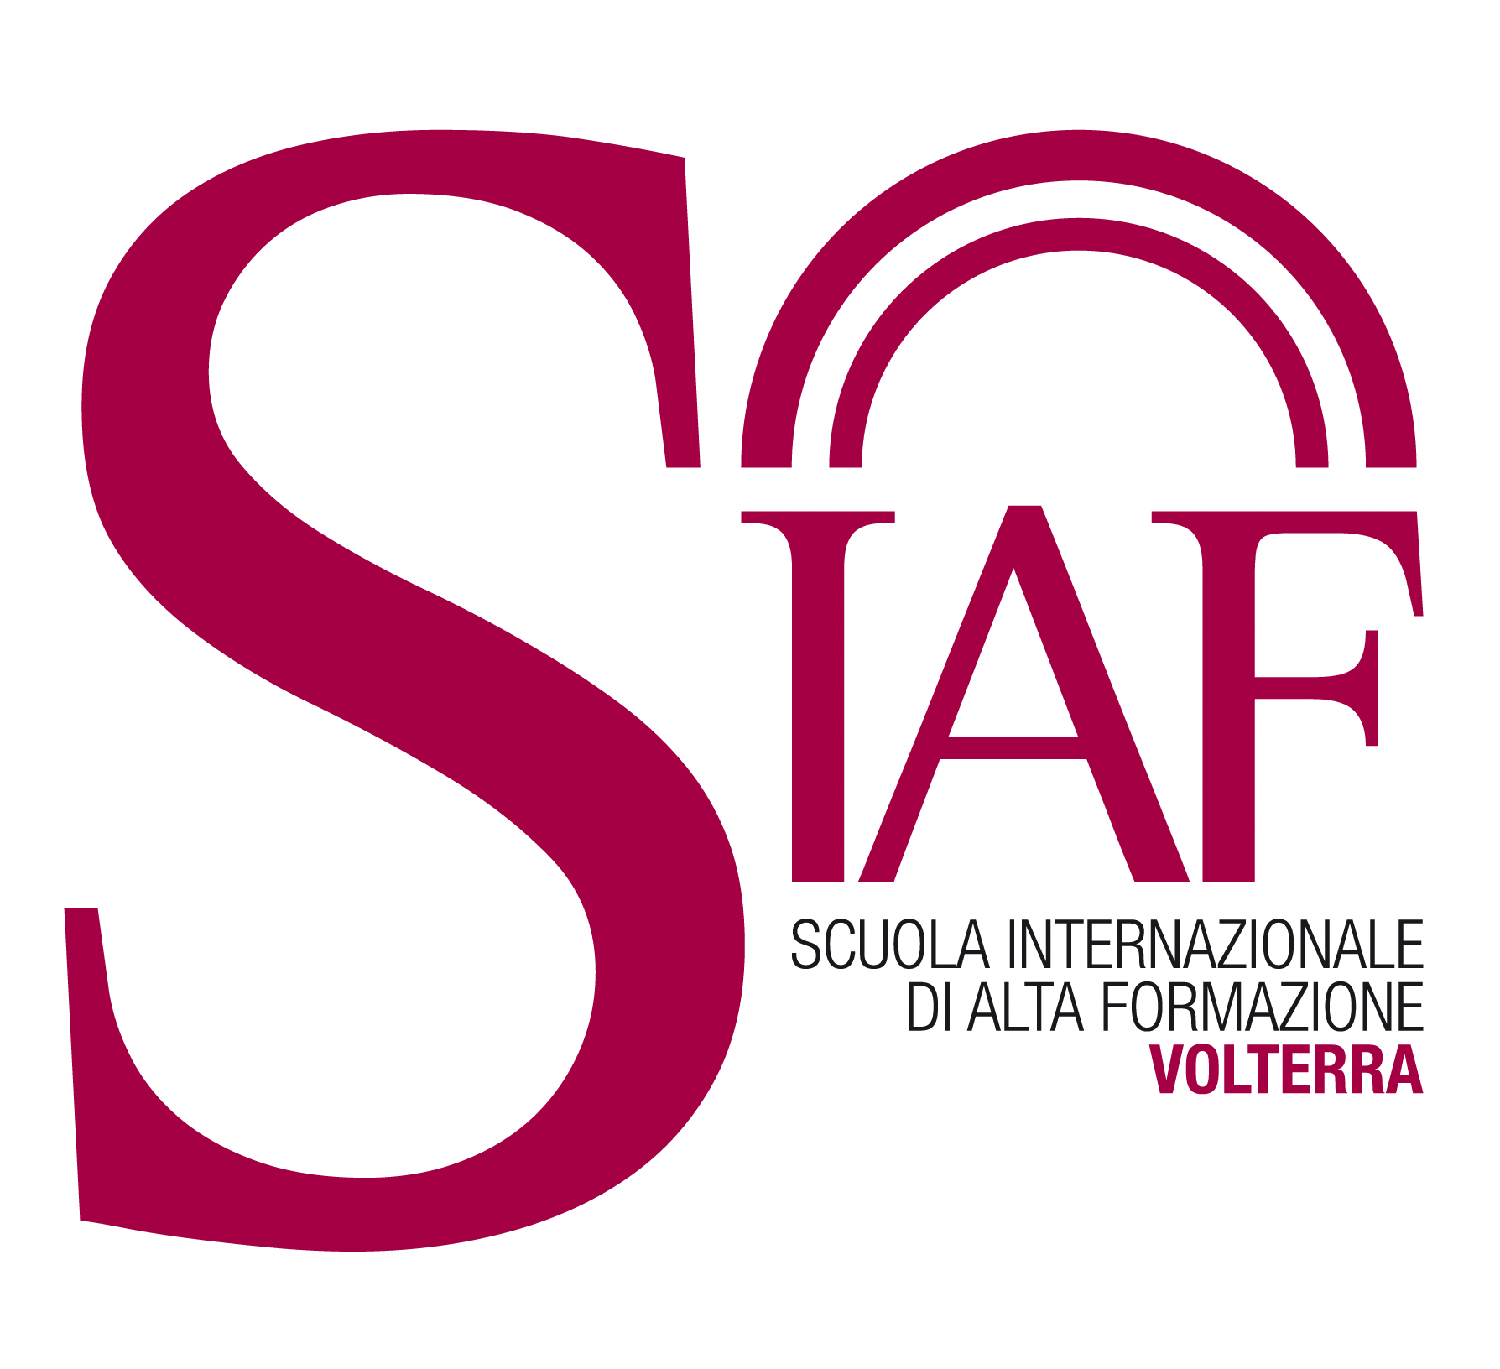

Call for Applications

Summer School
“Western civilization and culture: Renaissance and Modernity”

29th august – 10th September 2015
Sant'Anna School of Advanced Studies (Scuola Superiore Sant’Anna), Pisa-Volterra, Italy

An intense and involving learning experience in Top and Elite university of Italy

Lectures and on-the-spot investigation in Renaissance and modernity in their civilization and culture

Scuola Superiore Sant’Anna welcomes applications from Beihang University students and for a Summer School in Tuscany on “Western civilization and culture: Renaissance and Modernity.” You will attend exciting in-class lectures and seminars, discover cities rich in history and landscapes of outstanding beauty, explore UNESCO’s World Heritage Sites, visit best Italian universities and investigate traditional, modern and fashion industries. You will be amazed to find out how modernity, technology, fashion and food in this country have strong links with the past.

2 Credits will be recognized in Beihang University after the summer school.

The summer school is organized and staffed by scholars associated with Scuola Superiore Sant’Anna and Institute for Advanced Studies in Humanities and Social Sciences of Beihang University.

Enjoy your summer in the incredible beautiful sunshine of Tuscany!

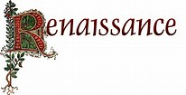
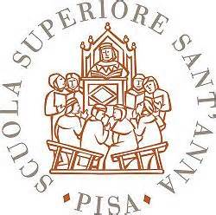
THE UNIVERSITY

Sant'Anna School of Advanced Studies (Scuola Superiore Sant’Anna)
Scuola Superiore Sant'Anna, located in Pisa (Tuscany), is a public university that holds a unique position within the Italian higher education system. It is small scaled and elite and is one of the three officially sanctioned special-statute universities in Italy. Potential undergraduates undergo a rigorous, open competitive entrance examination, and only the very best are selected (as of 2014, 50 freshmen are admitted per year), thus these students are called Honors College Students. Students live and study at the Scuola Superiore Sant'Anna totally free of charge; however, they are required to get top marks (at least 27/30) in all their exams and show proficiency in at least two foreign languages, otherwise they will be expelled.

Its rankings:
Sant'Anna School of Advanced Studies, Scuola Normale Superiore di Pisa and the University of Pisa create the mighty Pisa University System. Sant'Anna School of Advanced Studies has been given separate university status by the “Ministry of Education, Universities and Research” (Italy), and together with Scuola Normale Superiore di Pisa is leading the model of Scuole di Eccellenza, Superior Graduate School in Italy (Grandes écoles).
The Academic Ranking of World Universities puts “Pisa University System” at the first place in Italy (National Rank # 1) and within the best 30 universities in Europe.
Sant'Anna School of Advanced Studies has been mapped by Times Higher Education-QS World University Rankings as one of the most important educational institutions in Italy.
Sant'Anna School of Advanced Studies together with Scuola Normale Superiore is named as leading institutions in Italy's six top higher education institutes by Times Higher Education World University Rankings.
According to QS World University Rankings, Sant'Anna School of Advanced Studies is part of the initiative Invest Your Talent in Italy which puts Italian graduate programs on the world's stage.
The European Research Ranking, a ranking based on publicly available data from the European Commission database puts Pisa University System among the best in Italy and best performing European research institutions.
The official agency of the Italian Ministry of Education, Universities and Research (MIUR), the Agenzia nazionale di valutazione del sistema universitario e della ricerca (ANVUR) ranks Sant'Anna School of Advanced Studies the best small university for 2013 in Italy (National Rank # 1).

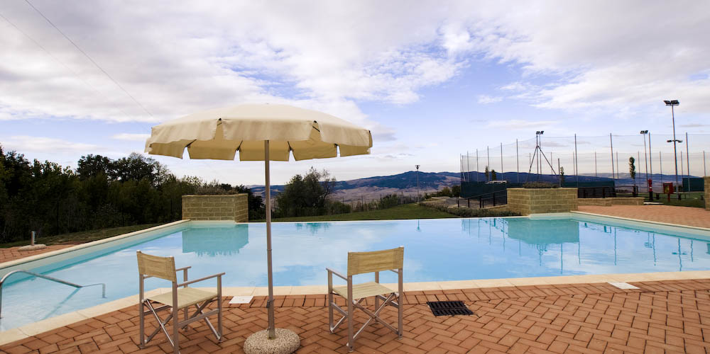
International School for Advanced Education (SIAF) of Scuola Superiore Sant’Anna
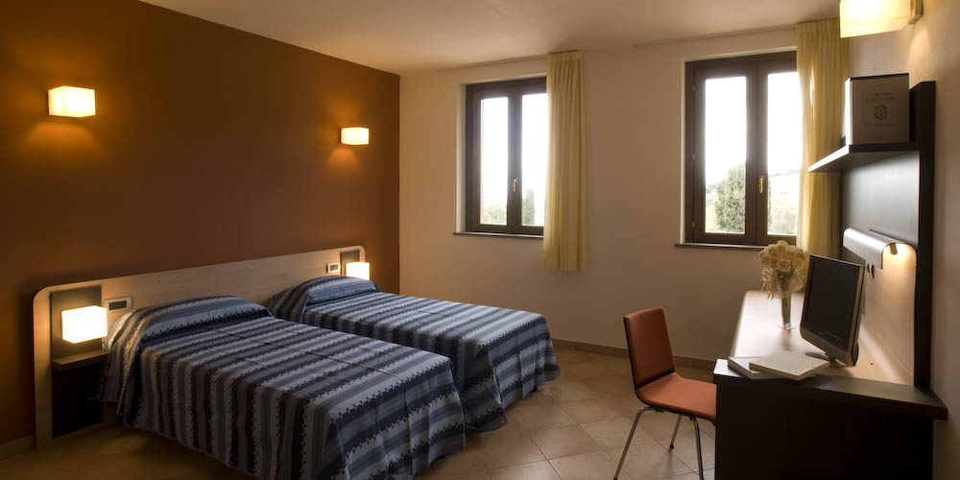
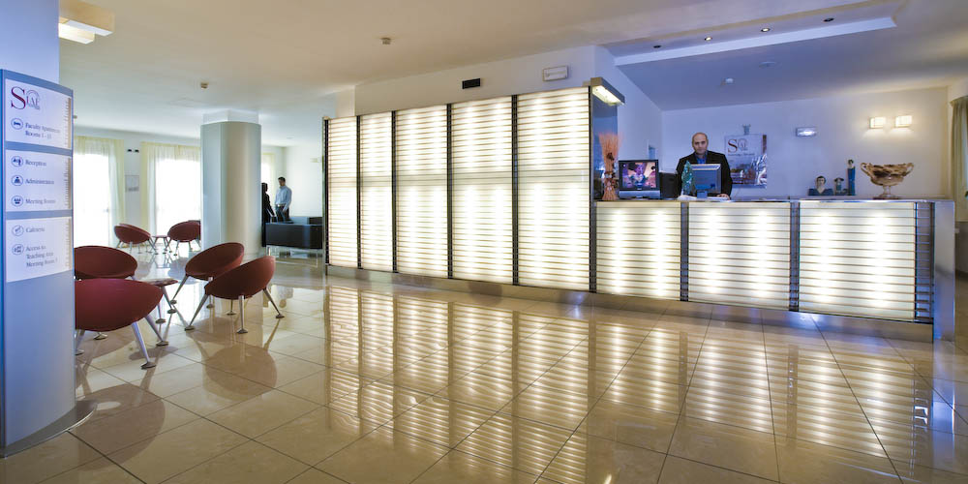
It is the first international residential executive campus in Italy. It provides a congenial environment for intensive study courses and conferences. The executive campus offers brand-new accommodation, well-appointed bedrooms with satellite TV, telephone, internet (wireless or ADSL) and air conditioning. The complex includes 7 multifunctional lecture rooms which can be partitioned and personalized as required, 2 spacious meeting halls and a recording room. All lecture rooms are equipped with up-to-date visual and audio aids: wireless internet, microphones, video projectors, overhead projectors and PCs. Spacious public areas are suitable for both indoor and outdoor activities, group work, performances, buffets, entertaining and relaxation.

Summer school program

Scuola Superiore Sant’Anna in partnership with Institute for Advanced Studies in Humanities and Social Sciences of Beihang University presents this

 | Theory study |  | On-the-spot investigations and field trips
 |  |  | Cities | Universities | Companies
August 29th | Arrival in Rome
August 30th |  |  | Rome
August 31st | Presentation and seminar |  | Volterra |  | Alabaster Handicraft Laboratories
September 1st |  |  | Venice
September 2nd |  |  | Venice
September 3rd | Seminar | Seminar
September 4th |  |  | Pisa | Scuola Sant’Anna  Pisa University | Piaggio Company
September 5th |  |  |  |  | Outlet,  Fashion Company
September 6th |  |  | Florence | Florence University
September 7th | Seminar | Seminar
September 8th |  |  | Bologna | Bologna University
September 9th | Seminar |  | Closing ceremony
September 10th | Departure for Beijing

﹡The international School of Advanced education of Scuola Superiore Sant’Anna will recognize to participants 2 credits.

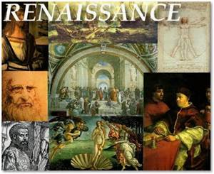
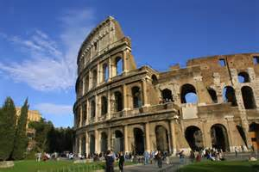

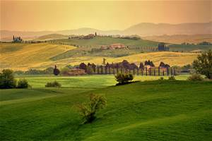

Your On-the-spot Investigations
and Field Trips

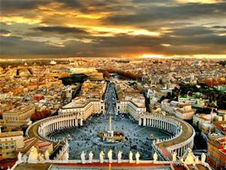
Rome and Vatican City
“Roma Aeterna” (The Eternal City) and “Caput Mundi” (Capital of the World), two central notions in ancient Roman culture.
One of the major centers of the Italian Renaissance.
Birthplace of the Baroque style.
18th-most-visited city in the world, 3rd most visited in the European Union, and the most popular tourist attraction in Italy.
Historic centre listed by UNESCO as a World Heritage Site.

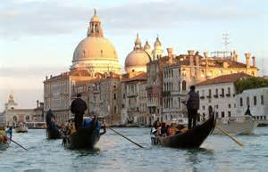
Venice
“Queen of the Adriatic”, “La Dominante”, “Serenissima”, “undoubtedly the most beautiful city built by man”.
The city in its entirety listed as a World Heritage Site by UNESCO, along with its lagoon.
Former capital of the Republic of Venice, a major maritime power during the Middle Ages and Renaissance, and a staging area for the Crusades.
Staging are for important artistic movements, especially the Renaissance period.

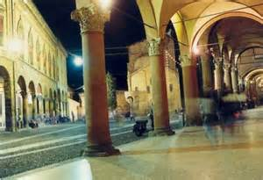
Bologna and its University
The largest city (and the capital) of the Emilia-Romagna Region in Italy.
Famous for its towers and lengthy porticoes, and a well-preserved historical centre (one of the largest in Italy).
An important cultural and artistic centre.
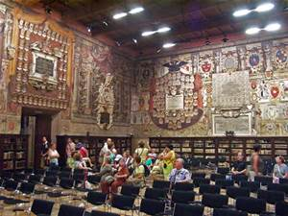
Homogenous mixture of monuments and architectural examples (medieval towers, antique buildings, churches, the layout of its historical centre) as well as works of art which are the result of a first class architectural and artistic history.
European capital of culture in 2000.
UNESCO “city of music” in 2006.
University of Bologna, the oldest university in the world, founded in 1088, Bologna hosts thousands of students who enrich the social and cultural life of the city.

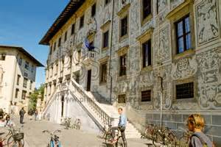
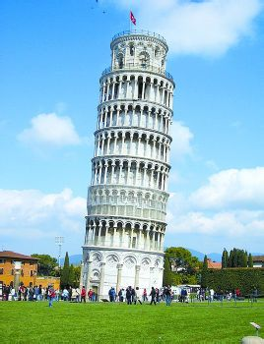
Pisa and its Universities
One of the most important cities in Tuscany.
Known worldwide for its leaning tower.
More than 20 historic churches, several palaces and various bridges across the River Arno.
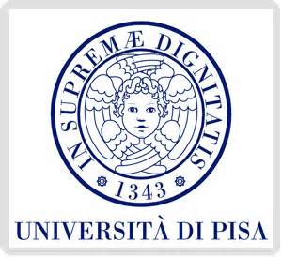
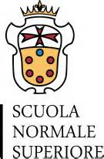
Home of the University of Pisa, which has a history going back to the 12th century, and also has the mythic Napoleonic Scuola Normale Superiore di Pisa and Scuola Superiore Sant’Anna as the best sanctioned Superior Graduate Schools in Italy.

Florence and its university
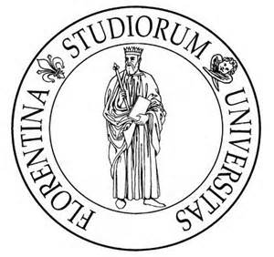
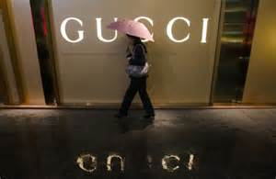
City founded by the Romans, characterized by straight roads which crossed at right angles.
One of the most exciting examples of Renaissance city
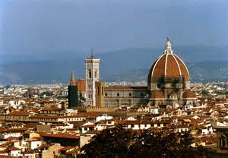
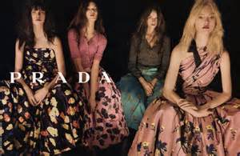
Born or have worked: Cimabue, Dante Alighieri, Giovanni Boccaccio, Filippo Brunelleschi, Leonardo da Vinci, Michelangelo.
Site of Uffizi Gallery, the most visited gallery in the world.
Florence University, founded in 1321, one of the most important Italian University.

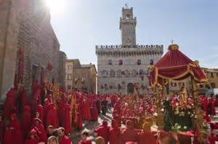
Volterra and its alabaster laboratories
One of the most important towns in Tuscany.
A Neolithic settlement and an important Etruscan center with an original civilization.
A municipium in the Roman Age.
Legendary hometown of vampire.

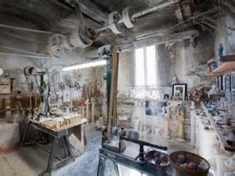
Shooting location of the movie Twilight.
Famous throughout the world for its age-old tradition of alabaster carving, a craft tradition that has been handed down by the Etruscan civilization.
We will organize a visit in a typical laboratory for an exciting experience.

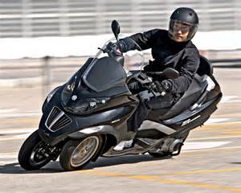
Piaggio Company and its museum
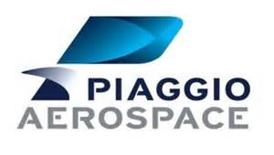
Founded in 1884, is a part of FCA (Fiat Chrysler group) producing motorcycle, one of the biggest industrial brands in Italy.

Costs & Application

RMB 30000 per person, including:
Air ticket
Visa application fee
Full board accommodation (Bedroom, breakfast, lunch and supper, use of gym and swimming pool on campus)
In-class seminars
Guided visit in cities, universities and companies
Selected museums
Transportation (shuttle go and return airport and cities, daily shuttle for and from Volterra city)

Candidate requirements
Students able to follow a lecture and participate in class discussions in English, the language used in all lectures and discussions and visiting.

Application
Fill out the application form and submit to Prof. Chen Qi via chenqi2013@buaa.edu.cn (e-mail titled as “summer school application -your name”)

Deadline of application: April 10th, 2015

Date of announcement: April 20th, 2015

For further information, please contact us: chenqi2013@buaa.edu.cn (E-mail titled as “summer school information-your name”)

Useful links:
www.sssup.it
http://www.buaa.edu.cn/zt/zt_qqhz/87822.htm
http://gyy.buaa.edu.cn

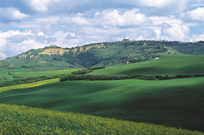
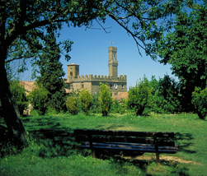

附件2：
Scuola Superiore Sant’Anna 2015 Summer School Application
姓名  Name |  |  | 学号  Student number
类别（本/硕）  Title |  |  | 院系  Department
性别  Gender |  |  | 籍贯  Domicile place
参加社会工作及特长
Extra curricular activities and special skills
联系电话  Telephone |  |  | 电子信箱  Email
英语水平  English language skills  (√) |  | 很好  Excellent |  | 好  Good |  | 一般  Satisfactory | 很差  Poor
英语水平  English language skills  (√) | 听Listening
英语水平  English language skills  (√) | 说Speaking
英语水平  English language skills  (√) | 读Reading
英语水平  English language skills  (√) | 写Writing
自我陈述
Statement
(Please explain why this summer school would be useful to you. Only in English, a maximum of 300 English words)
PLEASE fill out the form in both Chinese and English, except for STATEMENT.
除自我陈述用英文，其他请用中英文双语填写。

